Project Report

Morse code Generator by Analog Inputs

by

**Aditya Bontalakoti (522112), Sandeep Animireddi (522105)**

**EE203 PROJECT**

**Submitted on 23/11/23**

30/11/23

Table of Contents

1. List of the materials used.
2. Overview of the project.
3. Circuit Diagram
4. Operation of the project.
5. Importance of the project.
6. List of the materials used.

* A single XOR GATE
* Potentiometer (10K)
* Bread Board
* A 220 ohms Resistor
* Connecting wires
* Buzzer
* A led
* A Bulb or led
* Arduino Board

(2) Overview of the project.

The overall project is related to the concept of Analog and Digital Electronics. The project is a small miniature setup of the Morse code generator. Here the inputs of the Morse code can be manually controlled by analog inputs that are controlled by potentiometer. A XOR gate is used to control logic of High or Low

(3) Circuit Diagram.

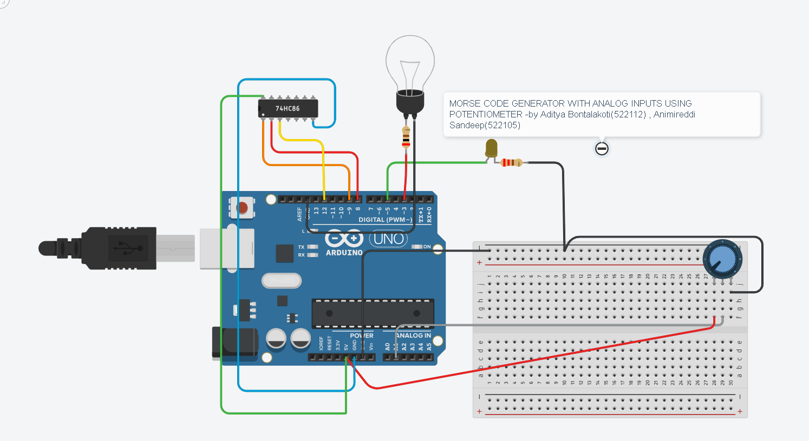

(4) Operation of Project

All the materials need to be connected in the fashion shown in the above diagram. We can also add a buzzer in the parallel across the blinking led. Connect the arduino to the laptop and dumb the code. The knob of the potentiometer can be varied from 0 to 255. If the value of the potentiometer is less than 125 , the blinking led gives DOTs and if the value of the potentiometer is more and equal to the 124 then the blinking led gives DASHs. The value of the potentiometer is shown in the output bar of the arduino software.

(5) Importance of project

The project can be used a basic instrument to code the language Morse, if the calibration is done correctly. Some of the future endeavors of this project are – we can code the language Morse by simply typing the info we want to encode. We can also use a sound sensor or photo resistor to decode it further. We can also do some encryption to protect the data.